Case Studies: UI Evaluation

Online Voting System

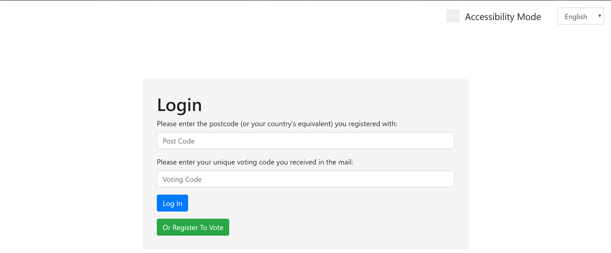

**Matt Stark, Shane Tandy, Ross Staniland & Dan Scott**

20/03/2019

Case Studies of Software Engineering

# Research Question:

**How is the user experience?**

# Quantitative Measures:

Questionnaires.

The reason for using this measurement is because we will get more meaningful data when compared to other quantitative measures that such as “time taken to submit a single vote”.

Whereas qualitative measures such as “User feedback” are much too vague compared to questionnaires which allow you to target multiple aspects of the user interface that they might have thought about at the time but were overshadowed by other features that may have grabbed their attention at the time. This would have been the focus of the user feedback and allows us to get a better overview of the system as a whole.

# 

# Consent Form:

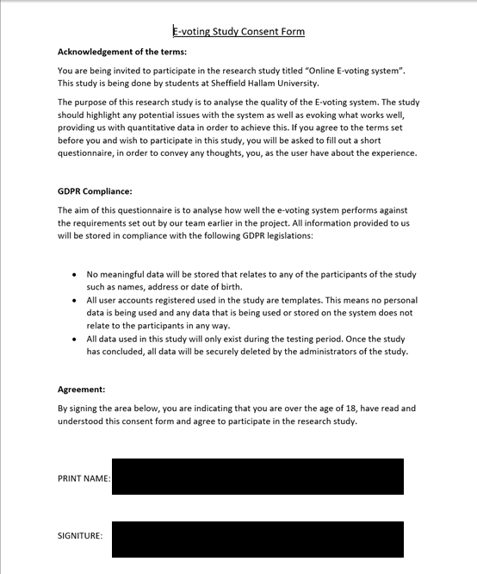

# Instructions

1. Register into the system providing your details (These details will not be kept after the evaluation)
2. Choose the vote “EU Referendum 2 - Electric Boogaloo”
3. Place a vote for the candidate you would like to back
4. Accept the confirmation box or go back and change your vote
5. Return to the Elections screen
6. Choose the vote “Best Pokemon Election”
7. Spoil your ballot
8. Return to the election screen
9. Logout
10. Feel free to look around any parts of the site you would like to in more detail
11. Inform the observer you are finished

# Experiment/Evaluation Plan

## **Scope**

· Specify how much of the product you will cover

Registering, Login, One First Past The Post Vote, one Preferential Voting vote, spoiling the ballot, logout

## **Purpose**

· Identify the concerns, questions, and goals for this evaluation. In each round, you will probably have several general and several specific concerns to focus on. Your concerns should drive the scenarios you choose for the evaluation

1. Test if users can perform all of these tasks on PC and Mobile

2. See if users prefer one interface to the other

3. Measure how usable each system is

4. Compare and contrast the usability of each voting type

5. Find out which features the users enjoy the most using a Likert Scale SUS document

## **Schedule & Location**

In a Sheffield Hallam University campus building or other open location at the request of the User.

## **Sessions**

· You will want to describe the sessions, the length of the sessions (typically one hour to 90 minutes*).

1. Sessions will take 10-20 minutes

2. Sessions will begin with explanation of the project

3. Users read and sign the consent form

4. Users are given the instructions to interact with the system

5. Users perform all tasks for the voting system as specified in the document

6. Users complete SUS form

7. Users are interviewed about their experience with the new voting system

## **Equipment**

· Indicate the type of equipment you will be using. Also indicate if you are planning on recording or audio taping.

1. Laptop computer with keyboard and trackpad

2. Mobile screen of a “Standard” size screen

3. Screenshots using the Windows Clipping tool / Smartphone Screenshot of choice

4. Timings made using the default Clock app of an Android phone

## **Participants**

· Indicate the number and types of participants you will be recruiting. Describe how these participants were or will be recruited, including documentation provided, such as consent forms.

Recruit at least 15 participants. All participants will be 25 or lower (as they are the most easily accessible, ideally we would have a mixed range but we do not have access to anyone of an older age) .

Participants to be recruited from our social networks. All participants received an instruction sheet and a consent form.

## **Scenarios**

· Indicate the number and types of tasks included in testing. Typically, for a 60 min. test, you should end up with approximately 10 (+/-2) scenarios for desktop or laptop testing and 8 (+/- 2) scenarios for a mobile/smartphone test.

1. Going through User related pages (Register, Login, Logout)

2. Going through Voting related pages (First past the post, Preferential Voting)

## **Subjective metrics**

· questions prior and after each task scenario, overall ease, satisfaction and likelihood to use/recommend when the sessions is completed. Usually participants rate the measure on a ***Likert scale***.

1. SUS questionnaire

## **Objective metrics**

· Indicate the observational data you will be measuring in your test (e.g., successful completion rates, error rates, time on task).

1. Time on Task

## **Roles**

· who does what. The usability specialist should be the facilitator of the sessions. Note-takers.

1. Single person acted as facilitator

2. Single person acted as time-keeper and note taker

2. Timings paused during screenshot to keep an accurate spreadsheet of timings

# Running the study/evaluation

Our first user started using the system and immediately mentioned that the registration page was a little annoying to them, as the modal they had to enter data into didnt show all of their information at once, which became apparent when they went back to check if they entered their first name. Fig 1

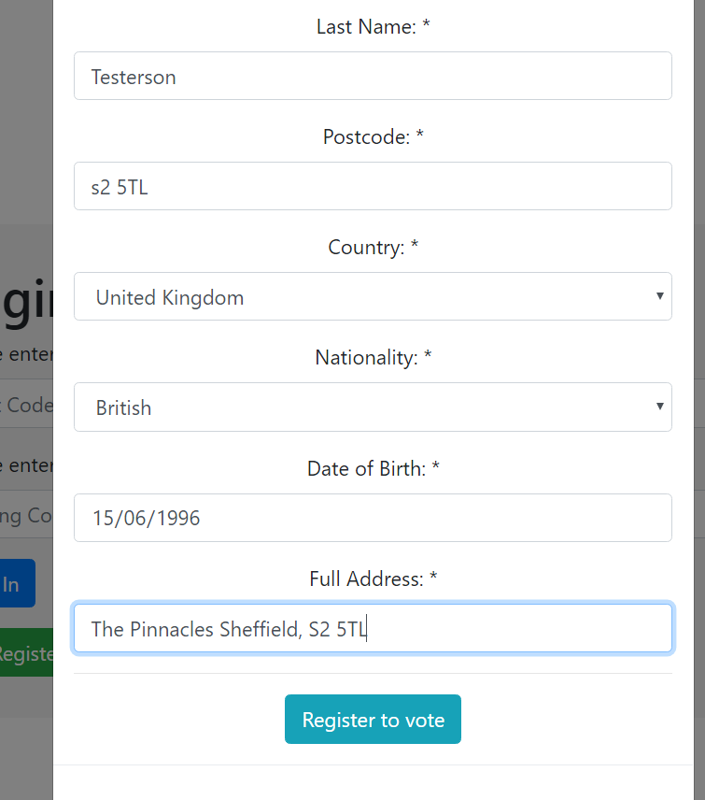

#### Fig 1 - User can’t see their first name on this screen

Users then complained about the alert that showed them their special key, however we are ignoring this piece of advice, as this was only to demonstrate the missing intermediary step of sending a letter to them in the post with it in discretely, but to maintain completeness in the report, see Fig 2

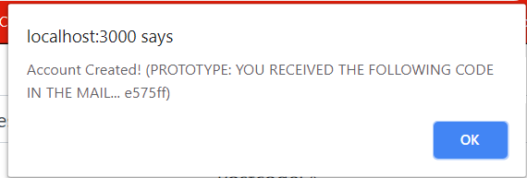

#### Fig 2 - User didn’t like this popping up out of nowhere

Users then got to the election page, nothing was out of place there, they mentioned that they liked the selection of each candidate for the First Past the Post voting system, see fig 3.

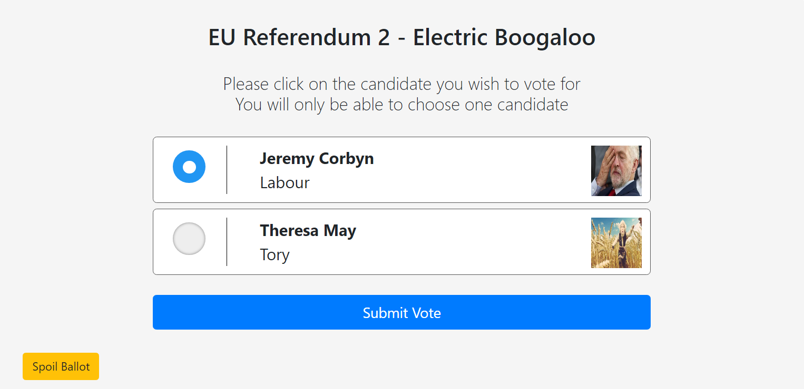

#### Fig 3- Blue negative space radio button was a frequently praised feature

Users then had a small gripe with how remain was displayed on the subsequent modal, however this was due to how the data was entered into the backend, and as such is something that can only be advised against in future created elections.

See Fig 4

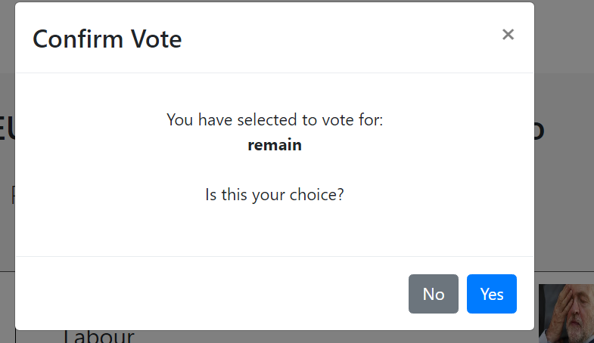

#### Fig 4 - remain in lower case

Users then finished the vote with no issues and continued onto the Preferential voting vote, Best Pokemon Election, they liked the layout of the page as it was quite easy to understand, One user attempted to drag and drop the votes from one side to another which would be a great improvement if we had more time to change the design See Fig 5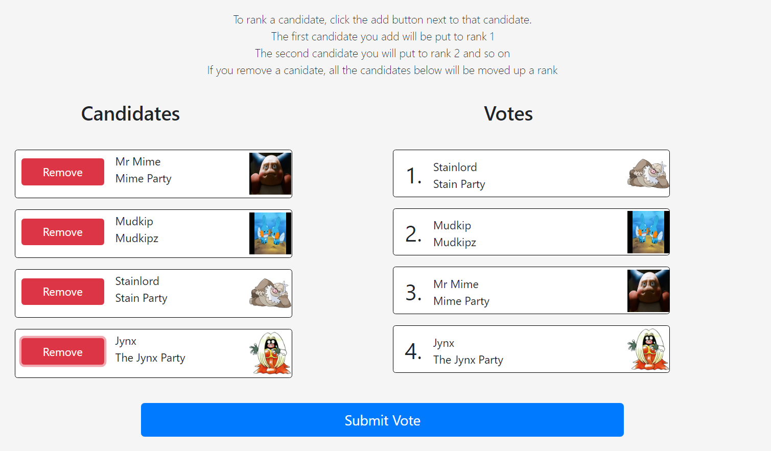

#### Fig 5 - Usage of Preferential Voting system.

Users found the rest of the system self explanatory.

However, during one of the tests, the user didn’t do the logout step so the subsequent user found that as soon as the server started they were served a start page that was very confusing as it was empty and only had a logout button. This was due to a redirect issue with sessions and was fixed thanks to user feedback. This also alerted us to potential security concerns with not logging out when the site is closed, this could be a future improvement See Fig 6

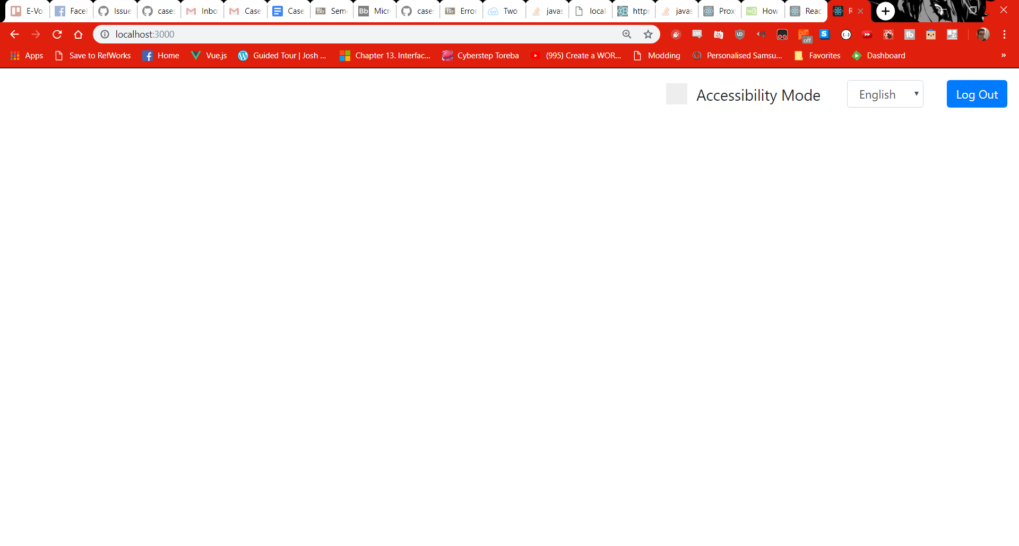

#### Fig 6 - Unsuccessful Redirect if the user had logged in previously on localhost:3000

# System Usability Scale Analysis

Time taken:

We asked our users to follow the instructions shown on page 2. We then timed how long it took them to carry them out. A table detailing the results are below:

|  |  |
| --- | --- |
| **Participant Number:** | **Time taken:** |
| 1 | 30.82 seconds |
| 2 | 30.01 seconds |
| 3 | 27.08 seconds |
| 4 | 33.48 seconds |
| 5 | 46.89 seconds |
| 6 | 58.11 seconds |
| 7 | 37.44 seconds |
| 8 | 29.63 seconds |
| 9 | 38.15 seconds |
| 10 | 34.96 seconds |
| 11 | 30.10 seconds |
| 12 | 37.75 seconds |
| 13 | 29.45 seconds |
| 14 | 41.39 seconds |
| 15 | 40.56 seconds |

The following questionnaire is one we handed out to our 15 study participants. This section of the UI evaluation will focus on analysing those results, once done, we will conclude said results and suggest possible future improvements.

The link to the survey can be found here:

<https://goo.gl/forms/lsPSaoXR7nzdbv1i2>

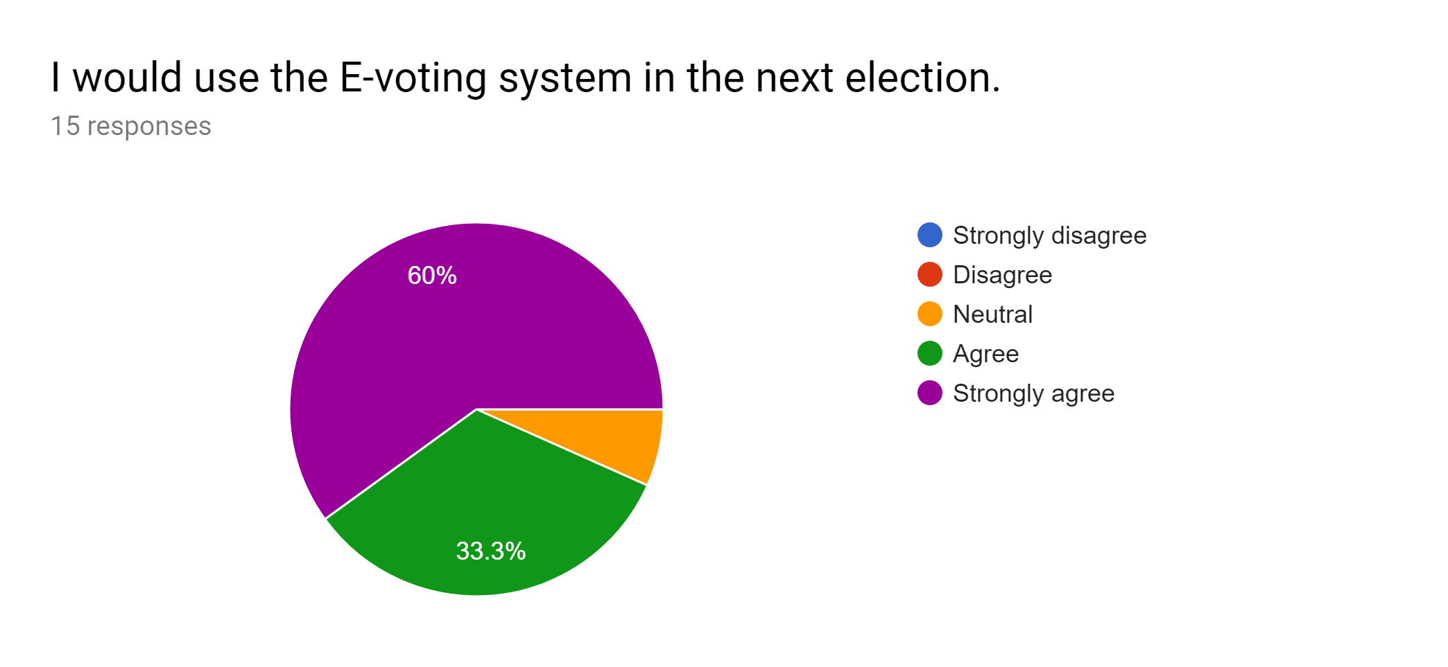[Fig 7]

This shows that the majority of our user base were very satisfied with the performance of the E-voting system. So much so that they would prefer to use it in the next election.

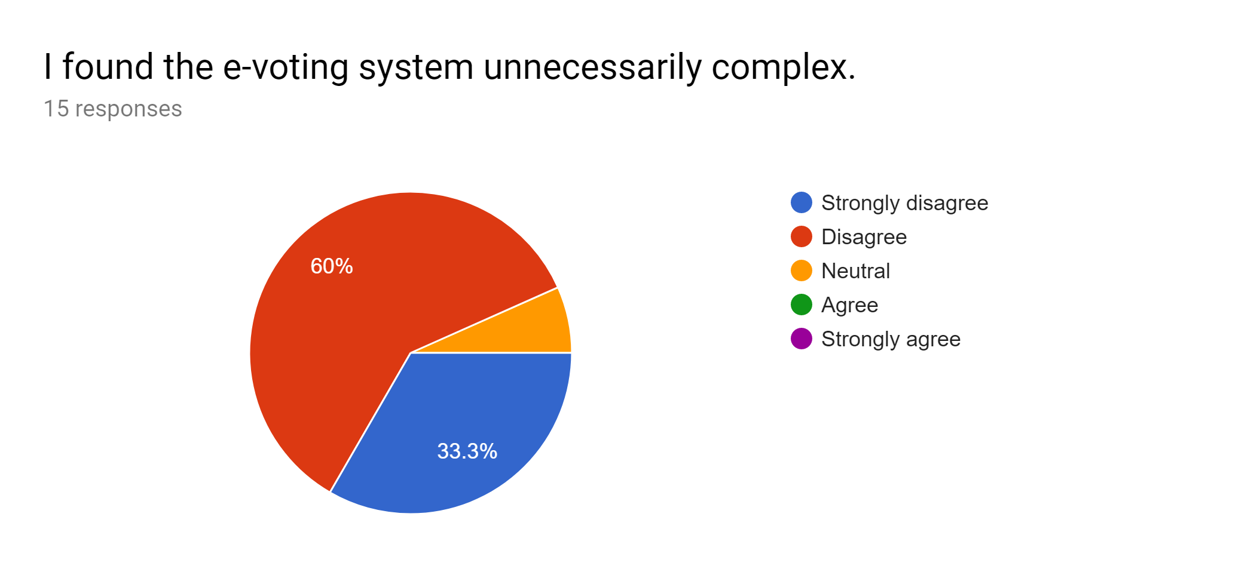

[Fig 8]

This is a positive result in that 93.3% of the people were satisfied with the level of complexity of the system and as shown in the results, none of our users found the system to be complex, with the exception of one user who was neither satisfied or dissatisfied.

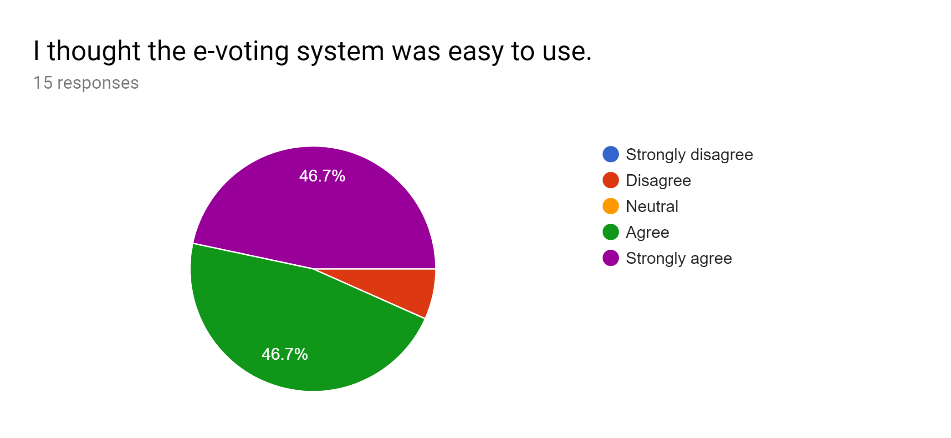

[Fig 9]

The results here are positive in that an overwhelming majority of users agreed the system was easy to use. We aimed to make the system as user-friendly as possible by eliminating the need for usernames and passwords, instead using the user’s post-code and voting code that they would receive in the post.

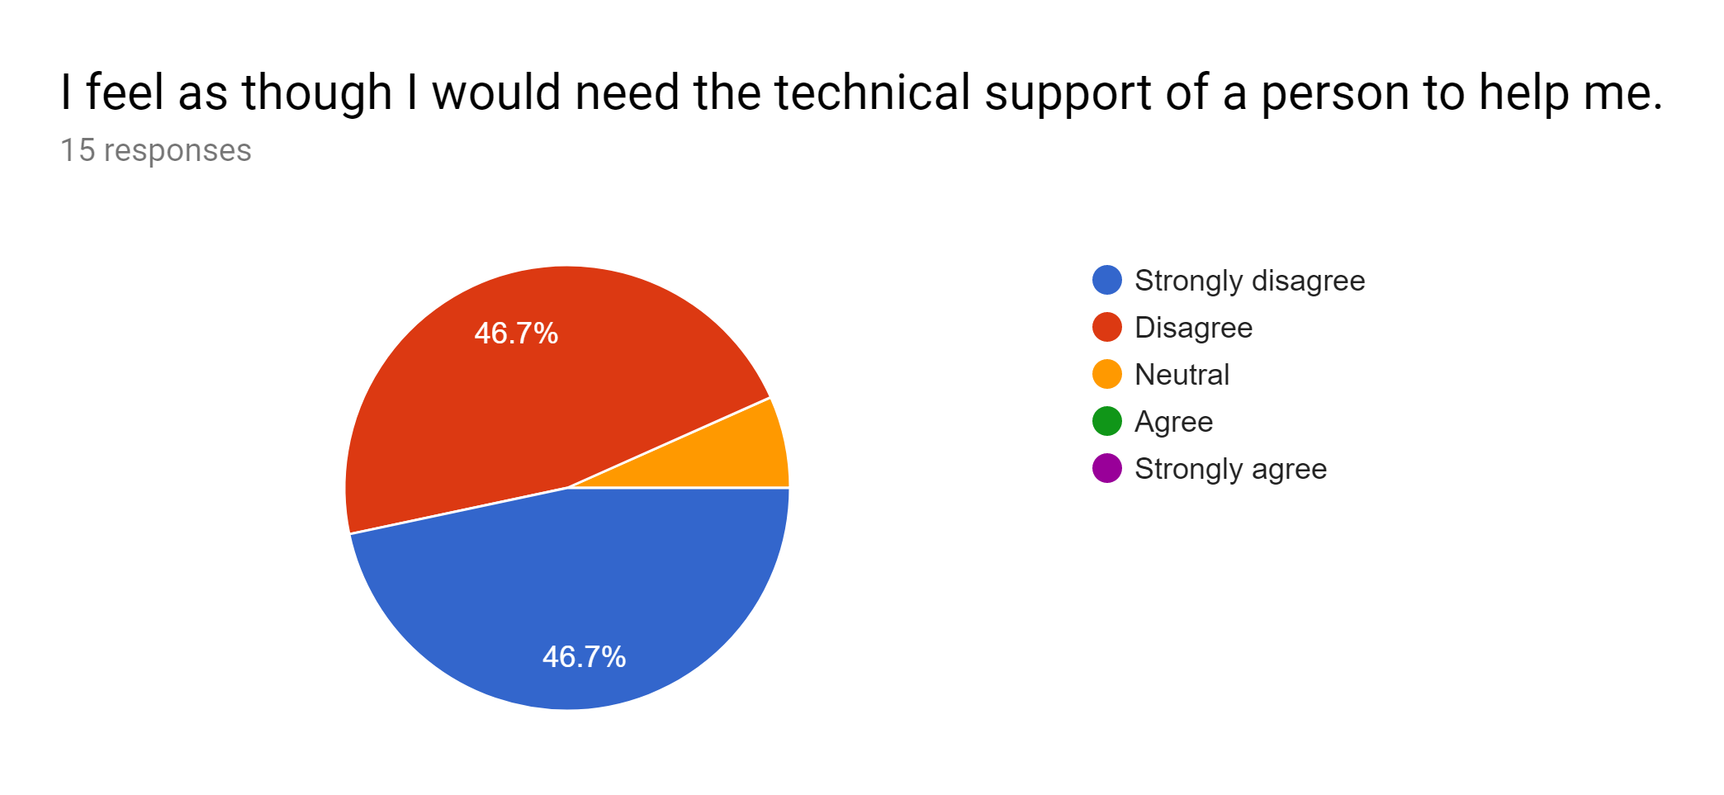

[Fig 10]

This was very important to us as it evokes the requirement to make the voting experience as user-friendly as possible. The fact 90% of the users said they disagreed or strongly disagreed with the statement shows it’s easily usable for people not accustomed to technology. It will speed up use of the website, so the remote users of the site will be able to vote without technical assistance.

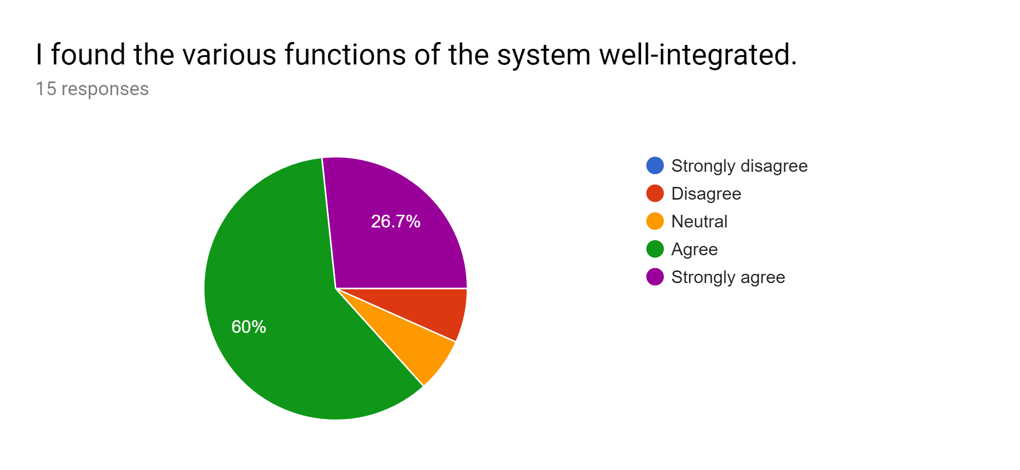

[Fig 11]

These results showed that 86.7% of users found the different functions we implemented fluid and functional. We asked our participants why the minority thought that and they justified their explanation by stating some of the functions were harder to notice than others.

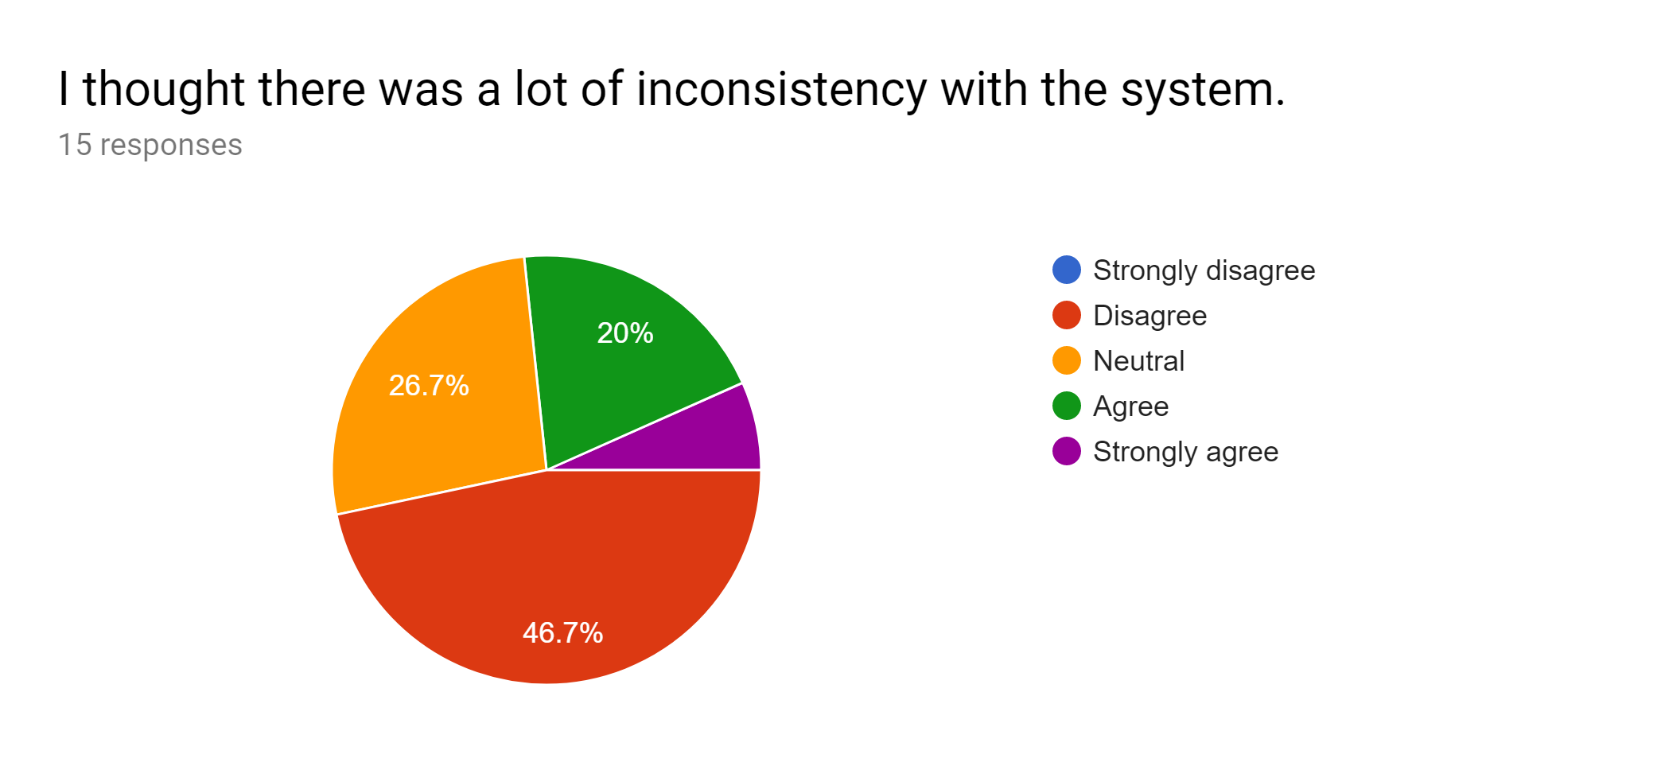

[Fig 12]

These results can be considered very intriguing. This is because the majority of people were either unsure with the consistency of program or believed it was inconsistent. On further analysis we determined this was because of the different bootstrap formatting on the both audit functions and mobile website displays.

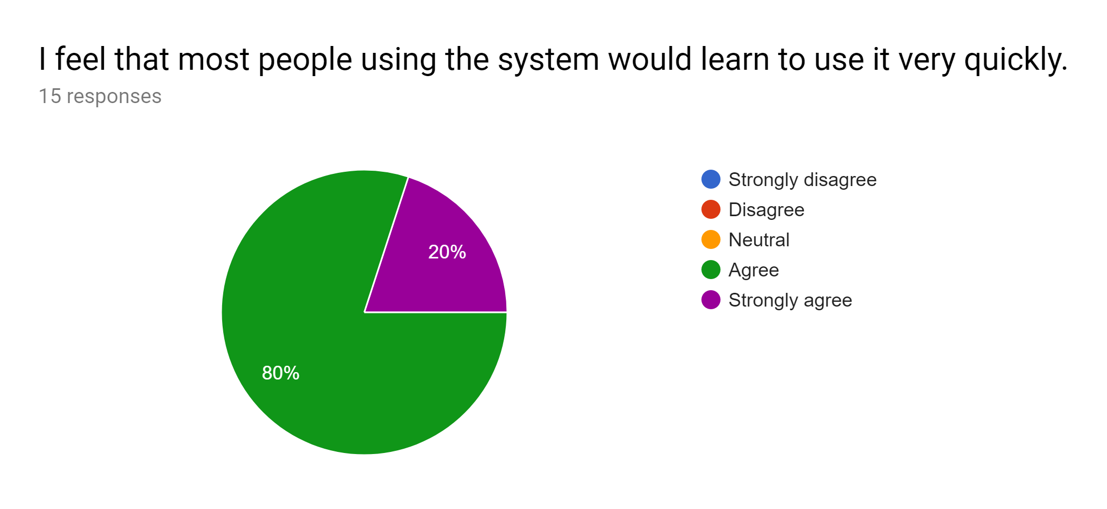

[Fig 13]

It was good to see here that no one disagreed that the ease of use in the system was very high. Meaning it’s safe to assume the website was intuitive enough for all users that took part in the study to be comfortable navigating the system.

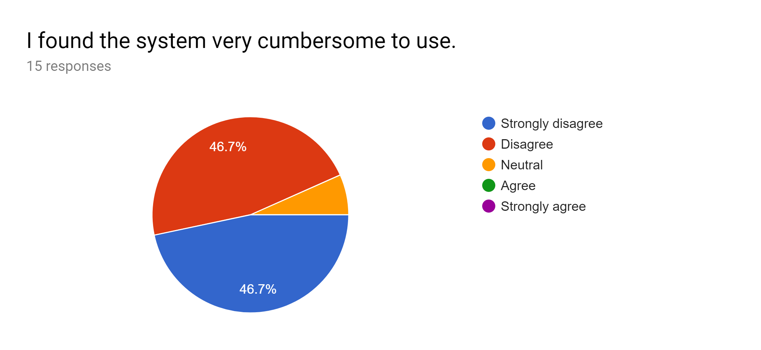

[Fig 14]

It was good to see the people who took part in the study did not find it cumbersome at all to use the system. Only one user voted that they felt neutral about this and upon further analysis, we came to the conclusion that they had not had any experience with an online voting system before and had nothing to compare it against.

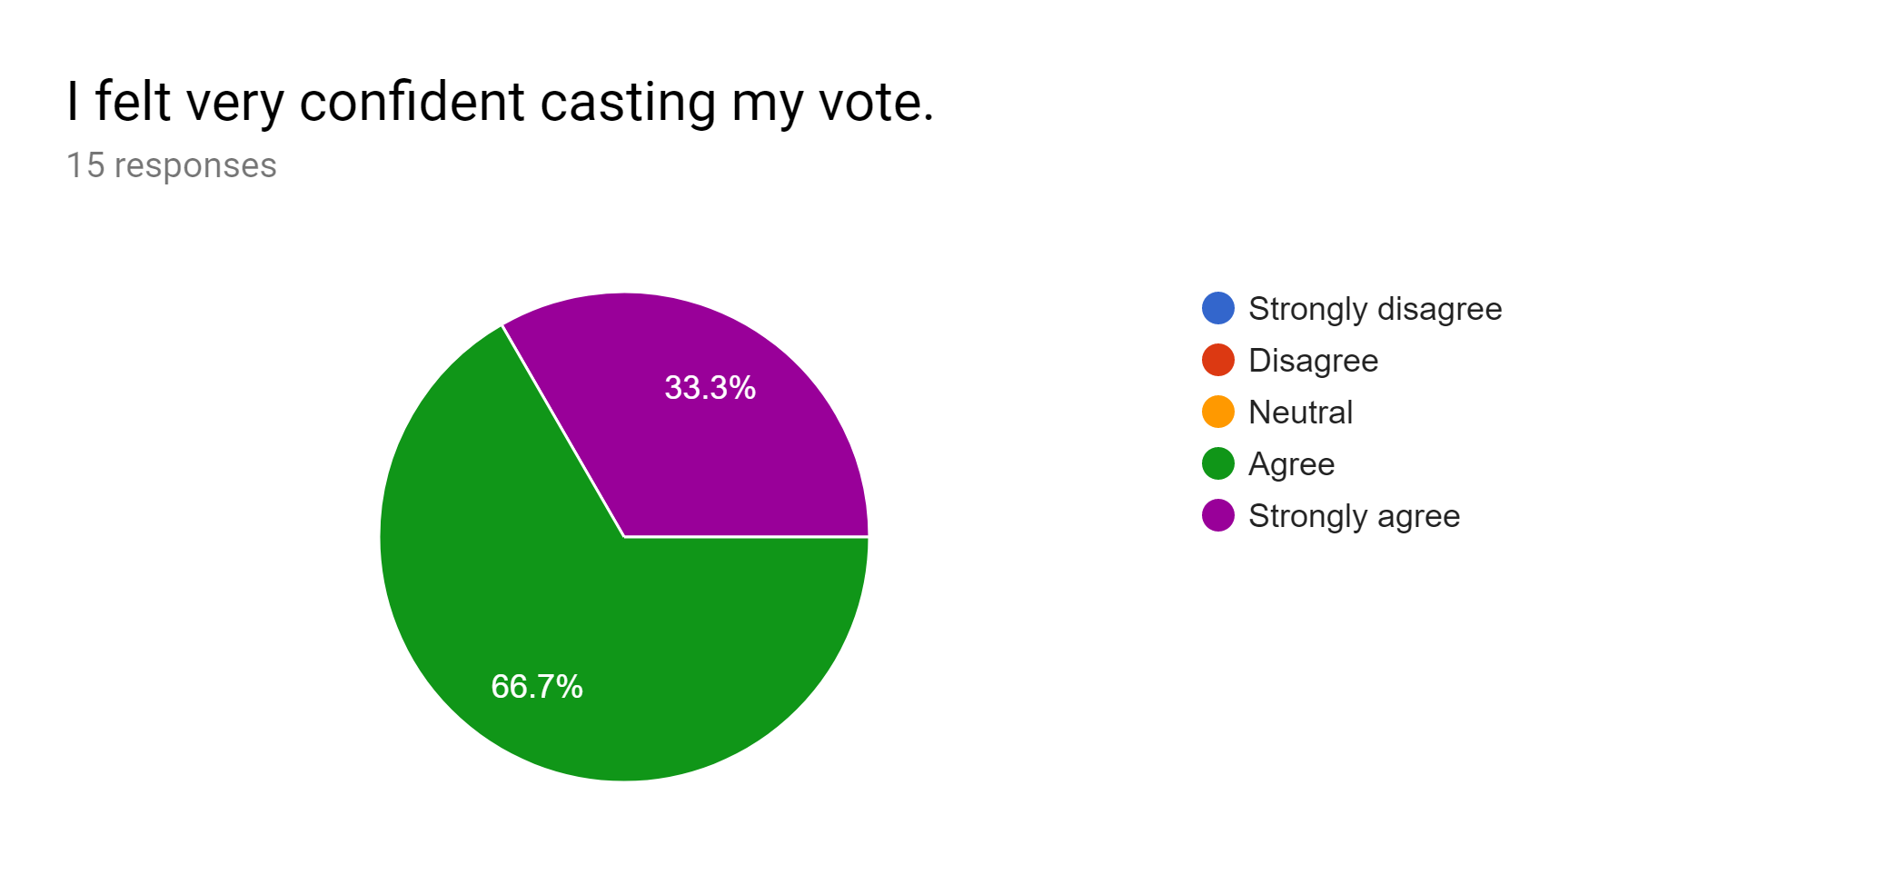

[Fig 15]

This was probably the most important aspect for us and it is good to see that 100% of users felt at least somewhat confident about casting their vote. This was important because it makes the users more inclined to use a system like this again if they felt they were a lot less likely to make any user errors when casting their vote.

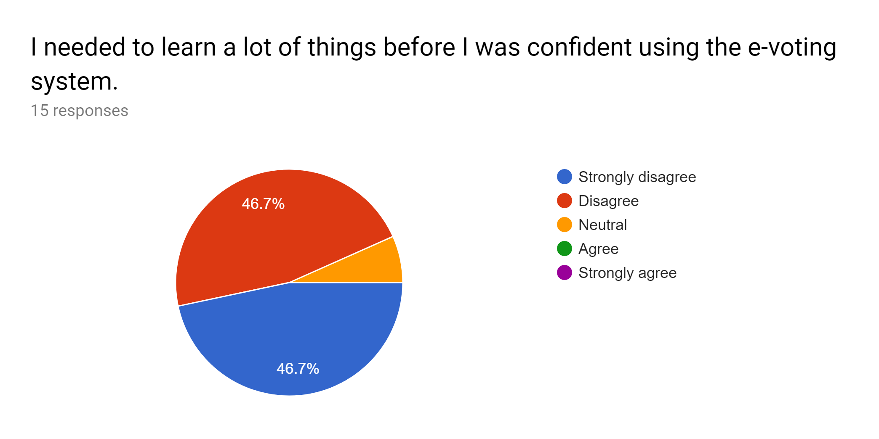

[Fig 16]

As we can see from these results, our user base did not need us to walk them through how to use the system. They were able to login with their user codes and follow the UI on screen in order to confidently cast their vote to their preferred politician.

## Future improvements:

From the results gathered, we as a team believe that the project is not without flaws and could see potential room for future improvements. We came to this conclusion by reviewing both the “inconsistency”(Fig 12) and “Various functions”(11) results. These show that there were a few inconsistencies with the layout and bootstrap of the site which in the future, we could change to comply with the general theme of the website. The other point made was that the functions we had needed to be more pronounced such as the language settings changing dynamic structures such as the elections rather than static data on the webpage.